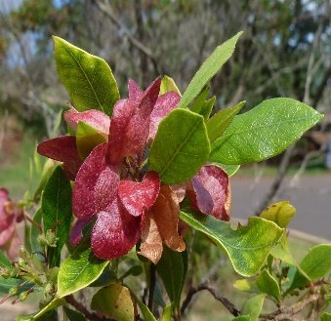
Women of Waiʻanae
“He ‘a‘ali‘i ku makani mai au; ‘a‘ohe makani nana e kula‘i.”-
I am a wind-resisting ‘a‘ali‘i, no gale can push me over. ~ ʻOlelo No`eau #57

A 501(c)(3) Charitable Organization
Tax ID: 99-0339323

Name: ______________________________________________________________________

Mailing Address: ______________________________________________________________

Home Phone: ___________________________ Cell Phone: ___________________________

Email Address: ________________________________________________________________
Ares of interest (check all that apply)

____ Events _____ Scholarship
____ Publicity _____ Fundraising
____ Membership _____ Other ___________________________________

One Year Membership: $20.00 ______

Signature: _________________________________ Date: _____________________________

Rules governing membership are outlined within the by-laws of the Women of Wai`anae. A copy of the by-laws are available to all individuals intending on becoming a member. It is the responsibility of the individual completing this document to understand the rules governing membership.

Application may be emailed to kgsyoung@hotmail.com after paying membership fees on website. Or mail to Karen Young at 86-024 Glenmonger St, Waianae, HI 96792 with check payable to Women of Waianae.

~~~~~~~~~~~~~~~~~~~~~~~~~~~~~~~~~~~~~~~~
This section is to be completed by the Membership Committee

Received by: ________________________________ Date Received: _____________________

